SUMO Project

1. I downloaded the SUMO.owl file. First, I downloaded from highlighted link then from the Blackboard code resource.

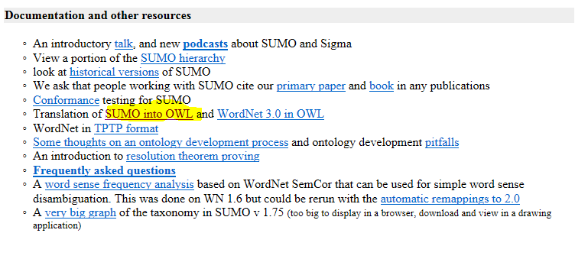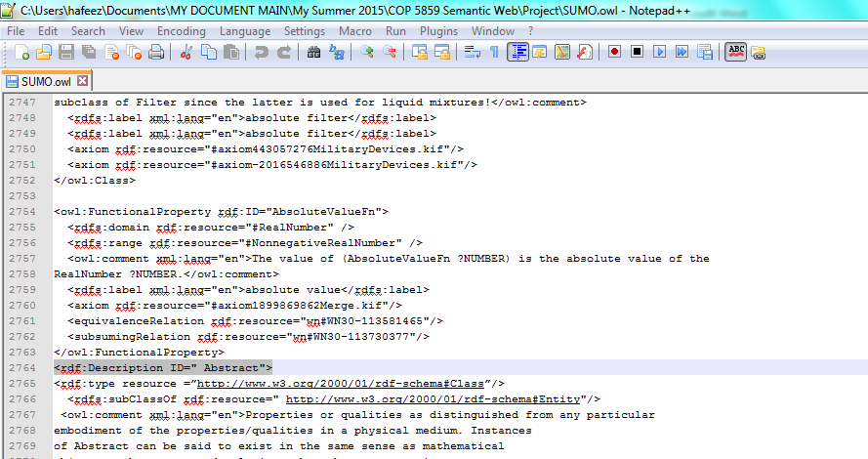

1. I tried to find the ontology hierarchy and found this picture.

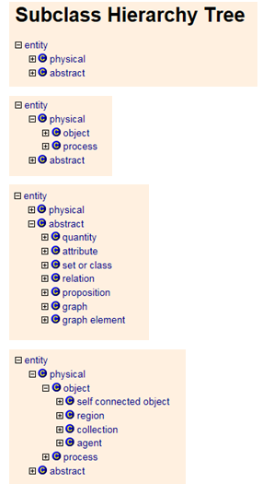

1. I found two main classes:
   1. Physical
   2. Abstract
2. Ran SUMO.owl on protégé and this result came: 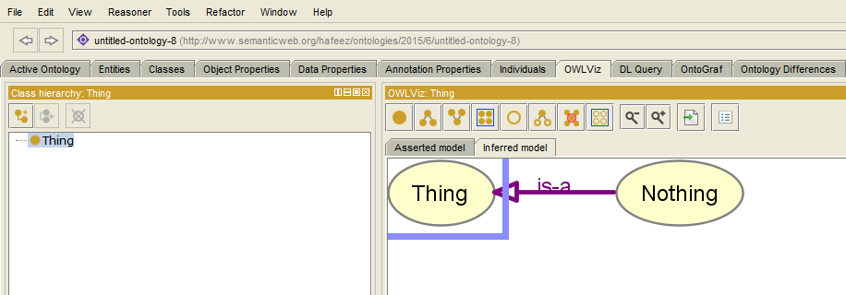
3. Located main class (physical and abstract) code on SUMO.owl file as shown:

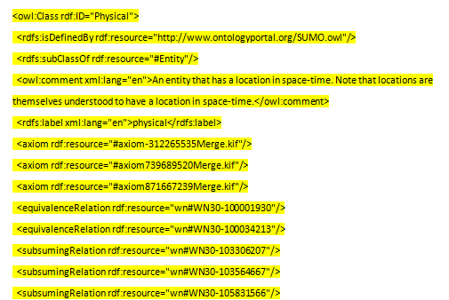

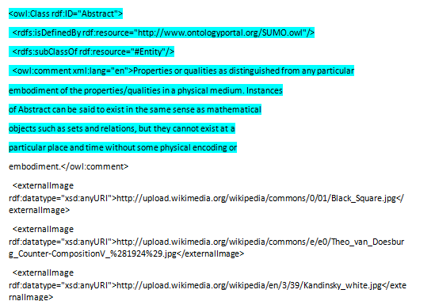

1. Just to correct main classes-Its look like the classes are not defined correctly in codes. I am assuming the problems in these 2 lines:

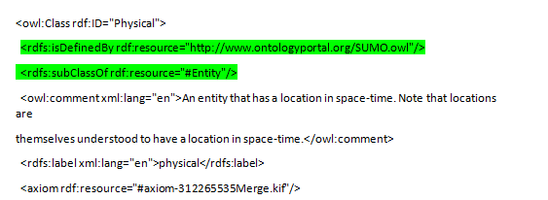

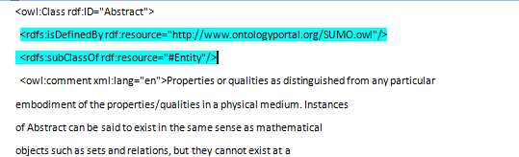

1. Changed core to run SUMO.Owl on protégé. Code Changed:

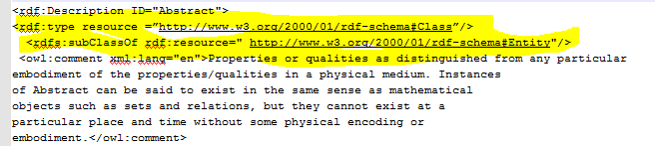

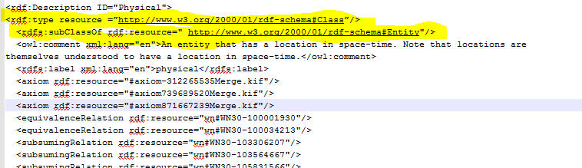

1. After running changed file getting this error on protégé:

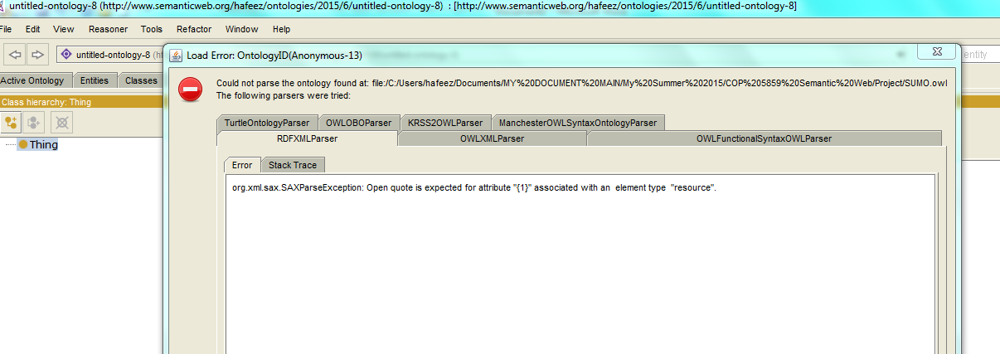

**Findings**: I found Syntax Problem in the Project

**Question**: Am going in the right direction?